UNITED STATES
SECURITIES AND EXCHANGE COMMISSION
Washington, D.C. 20549

FORM 8-K

CURRENT REPORT
PURSUANT TO SECTION 13 OR 15(d)
OF THE SECURITIES EXCHANGE ACT OF 1934

Date of Report (Date of earliest event reported): September 8, 2026

ORCHESTRA BIOMED HOLDINGS, INC.
(Exact name of registrant as specified in its charter)

Delaware  (State or other jurisdiction  of incorporation) | 001-39421  (Commission  File Number) | 92-2038755  (IRS Employer  Identification No.)
150 Union Square Drive
New Hope, Pennsylvania 18938
(Address of principal executive offices, including zip code)
Registrant’s telephone number, including area code: (215) 862-5797
(Former name or former address, if changed since last report)

Check the appropriate box below if the Form 8-K filing is intended to simultaneously satisfy the filing obligation of the registrant under any of the following provisions:

☐ | Written communications pursuant to Rule 425 under the Securities Act (17 CFR 230.425)
☐ | Soliciting material pursuant to Rule 14a-12 under the Exchange Act (17 CFR 240.14a-12)
☐ | Pre-commencement communications pursuant to Rule 14d-2(b) under the Exchange Act (17 CFR 240.14d-2(b))
☐ | Pre-commencement communications pursuant to Rule 13e-4(c) under the Exchange Act (17 CFR 240.13e-4(c))

Securities registered pursuant to Section 12(b) of the Act:

Title of each class | Trading Symbol(s) | Name of each exchange on which  registered
Common stock, par value $0.0001 per share | OBIO | The Nasdaq Global Market

Indicate by check mark whether the registrant is an emerging growth company as defined in Rule 405 of the Securities Act of 1933 (§230.405 of this chapter) or Rule 12b-2 of the Securities Exchange Act of 1934 (§240.12b-2 of this chapter).

Emerging growth company ☐

If an emerging growth company, indicate by check mark if the registrant has elected not to use the extended transition period for complying with any new or revised financial accounting standards provided pursuant to Section 13(a) of the Exchange Act. ☐

Item 7.01. | Regulation FD Disclosure.

A copy of a slide presentation that Orchestra BioMed Holdings, Inc. (the “Company”) uses at investor and industry conferences and presentations is attached to this Current Report on Form 8-K (“Current Report”) as Exhibit 99.1 and is incorporated herein solely for purposes of this Item 7.01 disclosure. Additionally, the Company has posted the slide presentation on its website at https://investors.orchestrabiomed.com under the Investor Relations section.

The information in Item 7.01 of this Current Report, including Exhibit 99.1 attached hereto, is being furnished and shall not be deemed “filed” for purposes of Section 18 of the Securities Exchange Act of 1934, as amended (the “Exchange Act”), or otherwise subject to the liabilities of such section. The information in Item 7.01 of this Current Report, including Exhibit 99.1, shall not be incorporated by reference into any filing under the Securities Act of 1933, as amended, or the Exchange Act, regardless of any incorporation by reference language in any such filing.

Item 9.01. | Financial Statements and Exhibits.

(d) Exhibits.

Exhibit  Number |  | Description
99.1 |  | Investor Presentation.
104 |  | Cover Page Interactive Data File (formatted as Inline XBRL and contained in Exhibit 101).

2

SIGNATURES

Pursuant to the requirements of the Securities Exchange Act of 1934, the registrant has duly caused this report to be signed on its behalf by the undersigned hereunto duly authorized.

 | ORCHESTRA BIOMED HOLDINGS, INC.
 | By: | /s/ Andrew Taylor
 | Name: | Andrew Taylor
 | Title: | Chief Financial Officer
Date: September 8, 2026

3

Exhibit 99.1

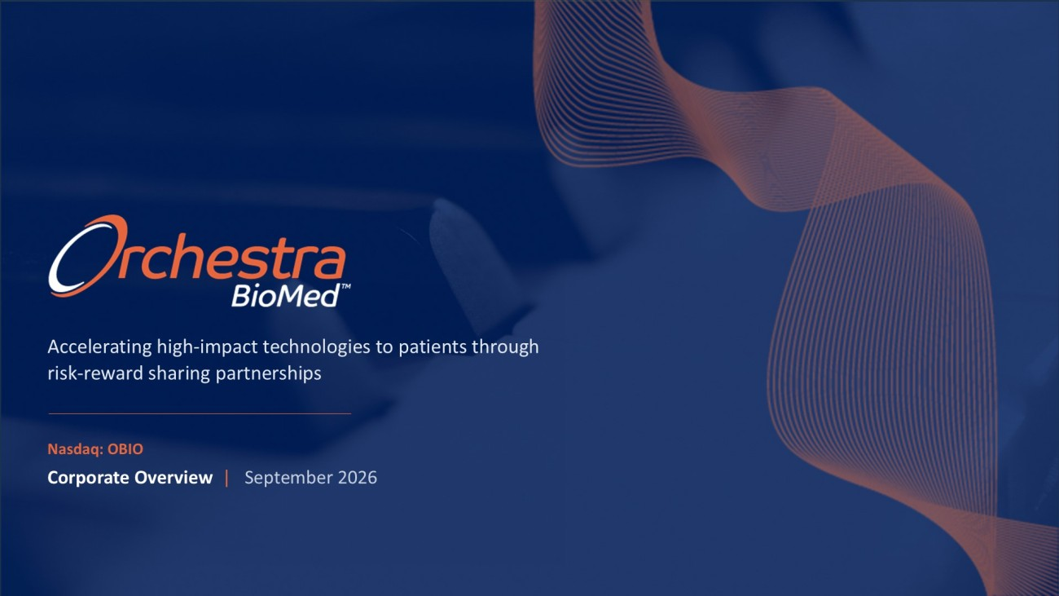
Accelerating high - impact technologies to patients through risk - reward sharing partnerships Corporate Overview | September 2026 Nasdaq : OBIO

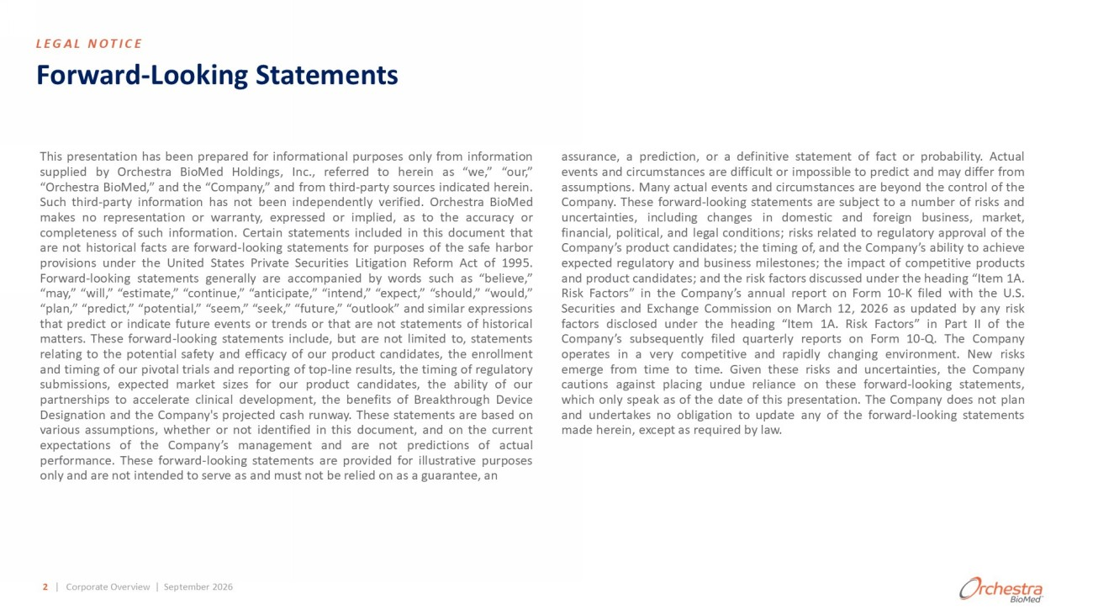
Forward - Looking Statements This presentation has been prepared for informational purposes only from information supplied by Orchestra BioMed Holdings, Inc . , referred to herein as “we,” “our,” “Orchestra BioMed,” and the “Company,” and from third - party sources indicated herein . Such third - party information has not been independently verified . Orchestra BioMed makes no representation or warranty, expressed or implied, as to the accuracy or completeness of such information . Certain statements included in this document that are not historical facts are forward - looking statements for purposes of the safe harbor provisions under the United States Private Securities Litigation Reform Act of 1995 . Forward - looking statements generally are accompanied by words such as “believe,” “may,” “will,” “estimate,” “continue,” “anticipate,” “intend,” “expect,” “should,” “would,” “plan,” “predict,” “potential,” “seem,” “seek,” “future,” “outlook” and similar expressions that predict or indicate future events or trends or that are not statements of historical matters . These forward - looking statements include, but are not limited to, statements relating to the potential safety and efficacy of our product candidates, the enrollment and timing of our pivotal trials and reporting of top - line results, the timing of regulatory submissions, expected market sizes for our product candidates, the ability of our partnerships to accelerate clinical development, the benefits of Breakthrough Device Designation and the Company's projected cash runway . These statements are based on various assumptions, whether or not identified in this document, and on the current expectations of the Company’s management and are not predictions of actual performance . These forward - looking statements are provided for illustrative purposes only and are not intended to serve as and must not be relied on as a guarantee, an assurance, a prediction, or a definitive statement of fact or probability . Actual events and circumstances are difficult or impossible to predict and may differ from assumptions . Many actual events and circumstances are beyond the control of the Company . These forward - looking statements are subject to a number of risks and uncertainties, including changes in domestic and foreign business, market, financial, political, and legal conditions ; risks related to regulatory approval of the Company’s product candidates ; the timing of, and the Company’s ability to achieve expected regulatory and business milestones ; the impact of competitive products and product candidates ; and the risk factors discussed under the heading “Item 1 A . Risk Factors” in the Company’s annual report on Form 10 - K filed with the U . S . Securities and Exchange Commission on March 12 , 2026 as updated by any risk factors disclosed under the heading “Item 1 A . Risk Factors” in Part II of the Company’s subsequently filed quarterly reports on Form 10 - Q . The Company operates in a very competitive and rapidly changing environment . New risks emerge from time to time . Given these risks and uncertainties, the Company cautions against placing undue reliance on these forward - looking statements, which only speak as of the date of this presentation . The Company does not plan and undertakes no obligation to update any of the forward - looking statements made herein, except as required by law . 2 | Corporate Overview | September 2026 LEGAL NOTICE

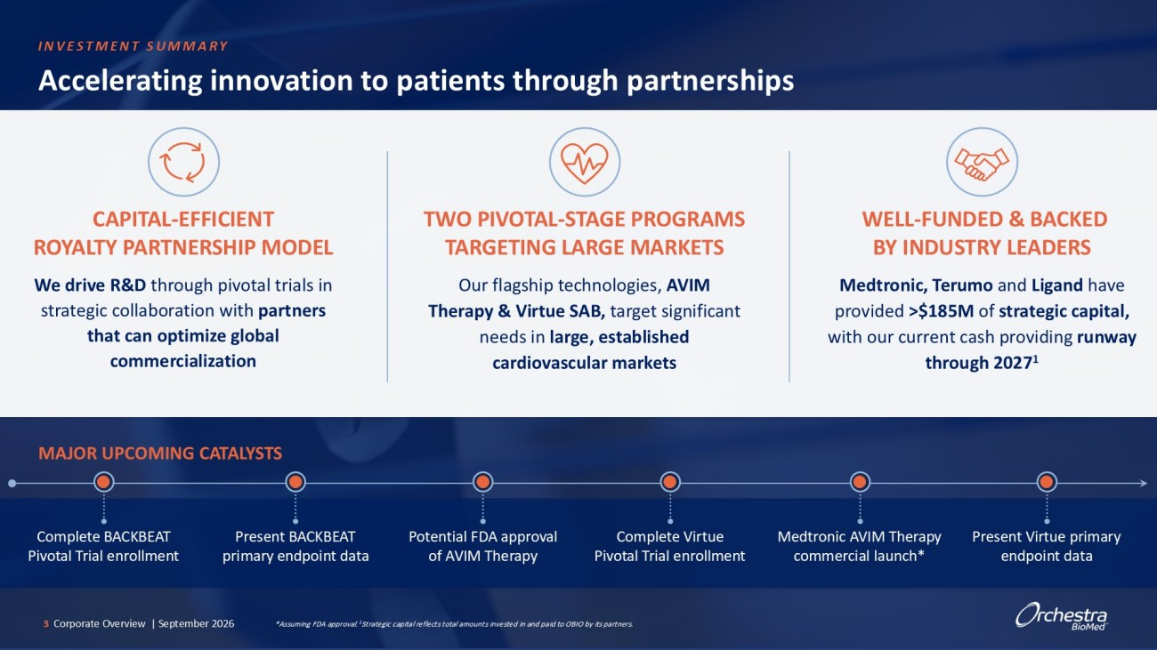
Accelerating innovation to patients through partnerships CAPITAL - EFFICIENT ROYALTY PARTNERSHIP MODEL We drive R&D through pivotal trials in strategic collaboration with partners that can optimize global commercialization TWO PIVOTAL - STAGE PROGRAMS TARGETING LARGE MARKETS Our flagship technologies, AVIM Therapy & Virtue SAB, target significant needs in large, established cardiovascular markets 3 Corporate Overview | September 2026 MAJOR UPCOMING CATALYSTS WELL - FUNDED & BACKED BY INDUSTRY LEADERS Medtronic, Terumo and Ligand have provided >$185M of strategic capital, with our current cash providing runway through 2027 1 Potential FDA approval of AVIM Therapy Complete Virtue Pivotal Trial enrollment Medtronic AVIM Therapy commercial launch* Present Virtue primary endpoint data *Assuming FDA approval. 1 Strategic capital reflects total amounts invested in and paid to OBIO by its partners. Complete BACKBEAT Pivotal Trial enrollment Present BACKBEAT primary endpoint data INVESTMENT SUMMARY

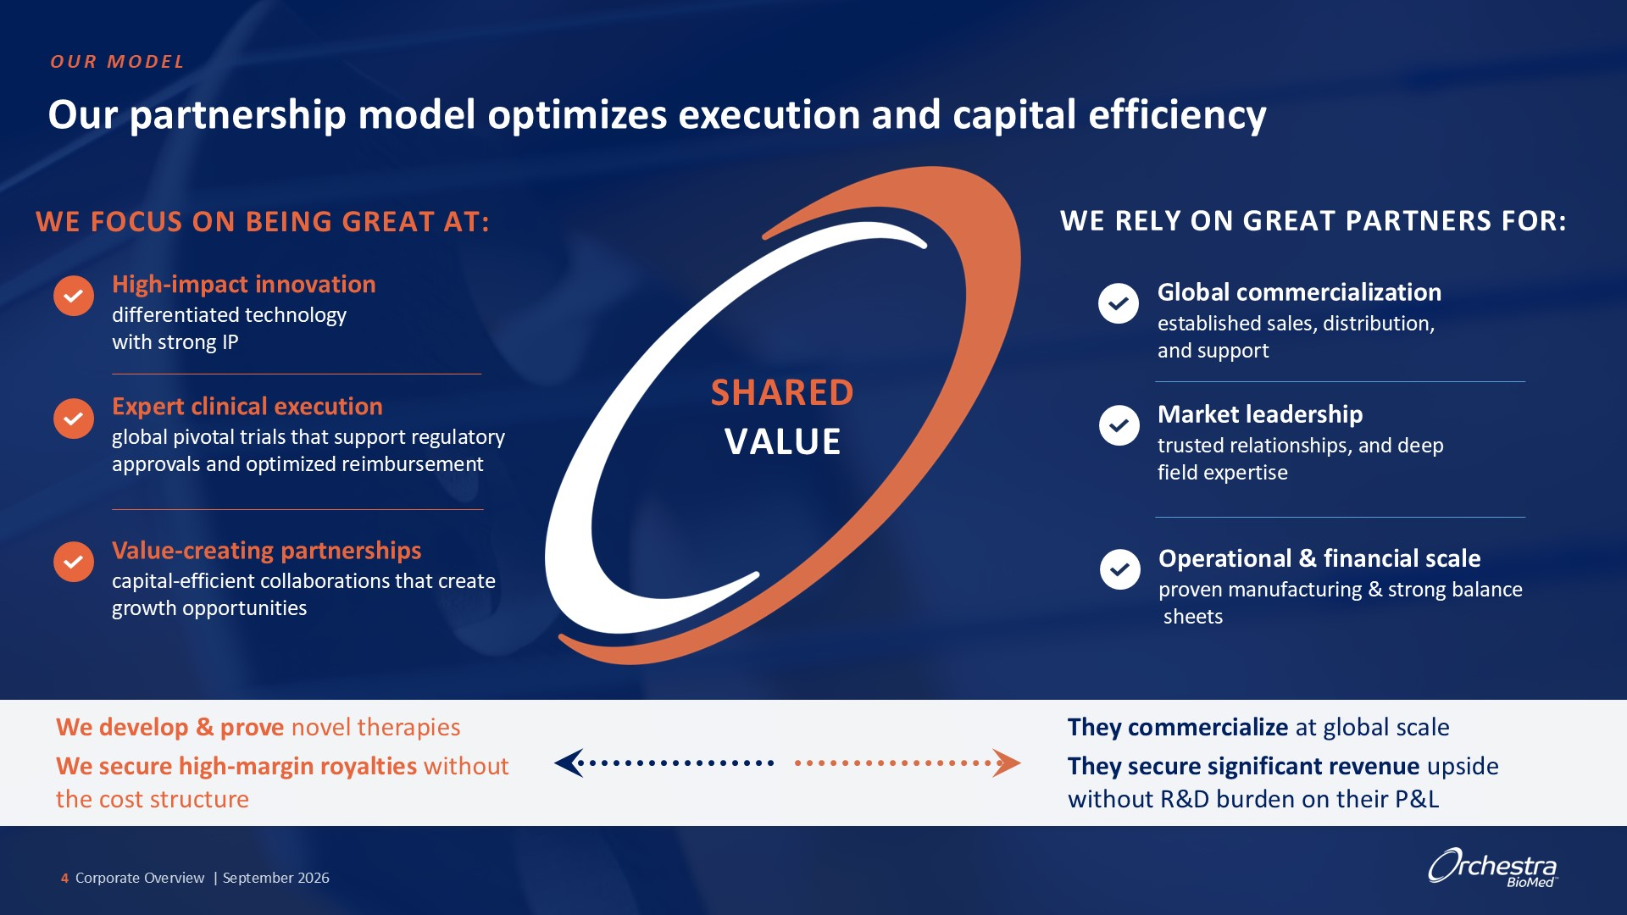
Our partnership model optimizes execution and capital efficiency WE FOCUS ON BEING GREAT AT: High - impact innovation differentiated technology with strong IP Expert clinical execution global pivotal trials that support regulatory approvals and optimized reimbursement Value - creating partnerships capital - efficient collaborations that create growth opportunities SHARED VALUE WE RELY ON GREAT PARTNERS FOR: Global commercialization established sales, distribution, and support Market leadership trusted relationships, and deep field expertise proven OUR MODEL 4 Corporate Overview | September 2026 We develop & prove novel therapies We secure high - margin royalties without the cost structure They commercialize at global scale They secure significant revenue upside without R&D burden on their P&L

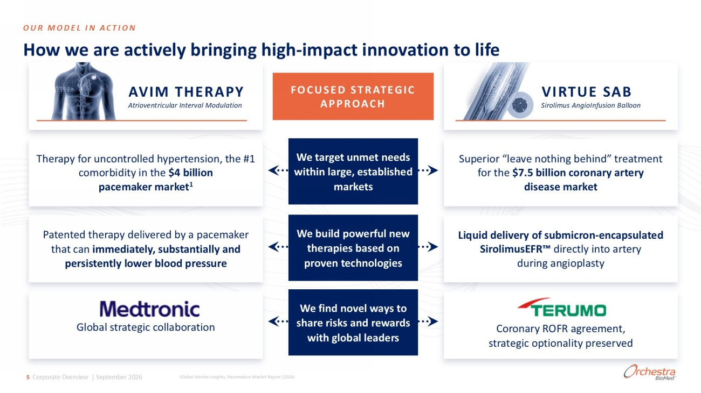
Therapy for uncontrolled hypertension, the #1 comorbidity in the $4 billion pacemaker market 1 Patented therapy delivered by a pacemaker that can immediately, substantially and persistently lower blood pressure AVIM THERAPY Atrioventricular Interval Modulation FOCUSED STRATEGIC APPROACH OUR MODEL IN ACTION VIRTUE SAB Sirolimus AngioInfusion Balloon Superior “leave nothing behind” treatment for the $7.5 billion coronary artery disease market Liquid delivery of submicron - encapsulated SirolimusEFR directly into artery during angioplasty We target unmet needs within large, established markets We build powerful new therapies based on proven technologies We find novel ways to share risks and rewards with global leaders Global strategic collaboration Coronary ROFR agreement, strategic optionality preserved 5 Corporate Overview | September 2026 How we are actively bringing high - impact innovation to life 1 Global Market Insights, Pacemakers Market Report (2024)

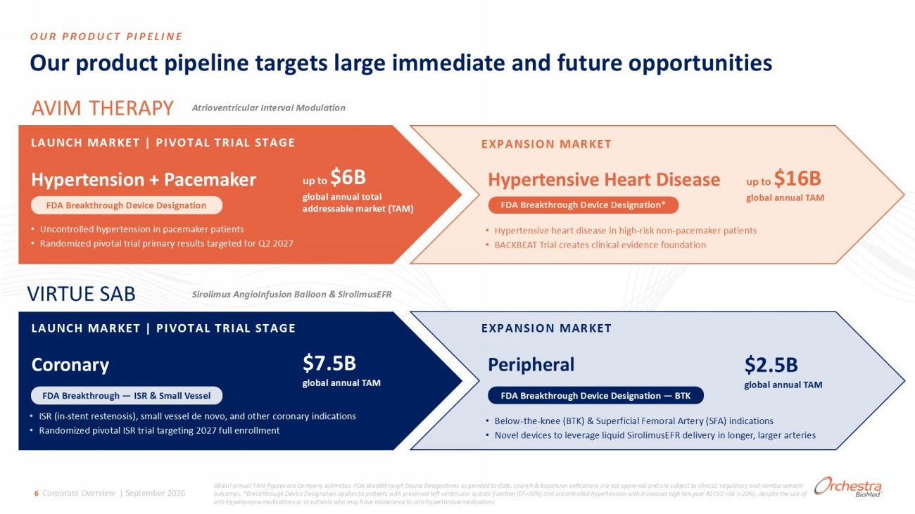
Our product pipeline targets large immediate and future opportunities OUR PRODUCT PIPELINE AVIM THERAPY Atrioventricular Interval Modulation LAUNCH MARKET | PIVOTAL TRIAL STAGE Hypertension + Pacemaker up to $6B global annual total addressable market (TAM) • Uncontrolled hypertension in pacemaker patients • Randomized pivotal trial primary results targeted for Q2 2027 FDA Breakthrough Device Designation EXPANSION MARKET Hypertensive Heart Disease up to $16B global annual TAM • Hypertensive heart disease in high - risk non - pacemaker patients • BACKBEAT Trial creates clinical evidence foundation FDA Breakthrough Device Designation* VIRTUE SAB Sirolimus AngioInfusion Balloon & SirolimusEFR LAUNCH MARKET | PIVOTAL TRIAL STAGE Coronary $7.5B global annual TAM • ISR (in - stent restenosis), small vessel de novo, and other coronary indications • Randomized pivotal ISR trial targeting 2027 full enrollment FDA Breakthrough — ISR & Small Vessel EXPANSION MARKET Peripheral $2.5B global annual TAM • Below - the - knee (BTK) & Superficial Femoral Artery (SFA) indications • Novel devices to leverage liquid SirolimusEFR delivery in longer, larger arteries FDA Breakthrough Device Designation — BTK Global annual TAM figures are Company estimates. FDA Breakthrough Device Designations as granted to date. Launch & Expansion ind ications are not approved and are subject to clinical, regulatory and reimbursement outcomes. *Breakthrough Device Designation applies to patients with preserved left ventricular systolic function (EF>50%) and un controlled hypertension with increased high ten - year ASCVD risk (>20%), despite the use of anti - hypertensive medications or in patients who may have intolerance to anti - hypertensive medications 6 Corporate Overview | September 2026

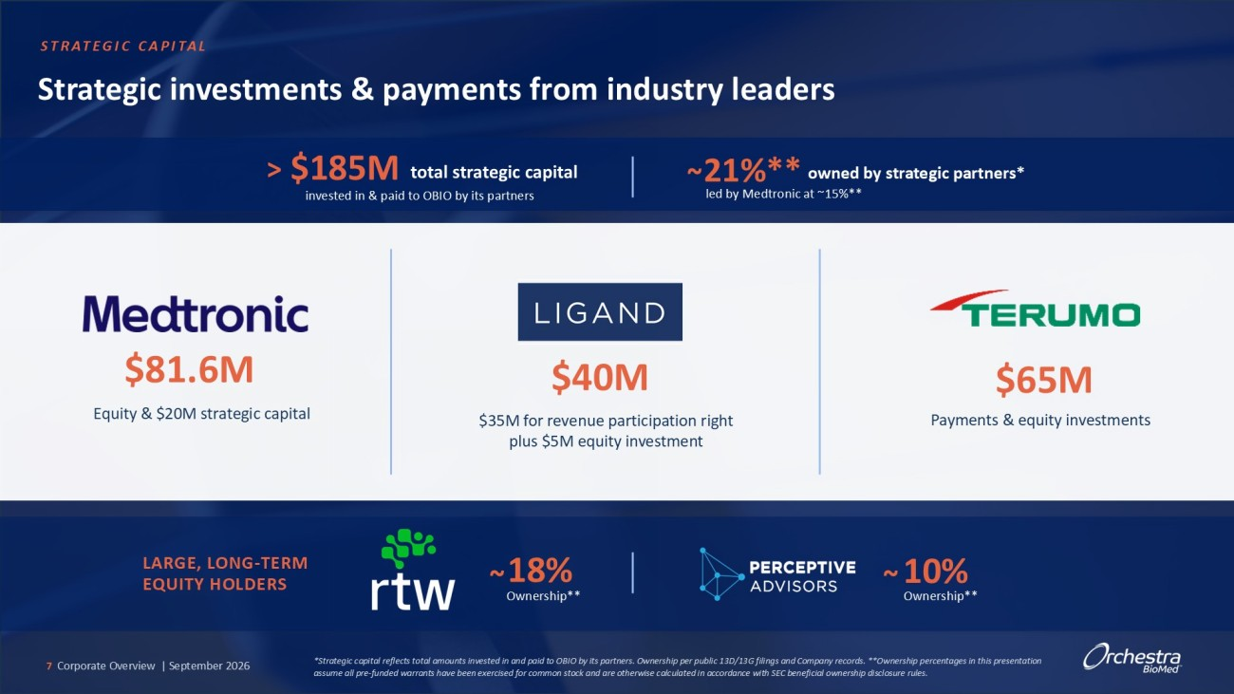
$185M > Strategic investments & payments from industry leaders total strategic capital invested in & paid to OBIO by its partners 21%** owned by strategic partners* led by Medtronic at ~15%** ~ $81.6M Equity & $20M strategic capital $40M $35M for revenue participation right plus $5M equity investment $65M Payments & equity investments LARGE, LONG - TERM EQUITY HOLDERS 18% ~ Ownership** 10% ~ Ownership** *Strategic capital reflects total amounts invested in and paid to OBIO by its partners. Ownership per public 13D/13G filings and Company records. **Ownership percentages in this presentation assume all pre - funded warrants have been exercised for common stock and are otherwise calculated in accordance with SEC benefici al ownership disclosure rules. STRATEGIC CAPITAL 7 Corporate Overview | September 2026

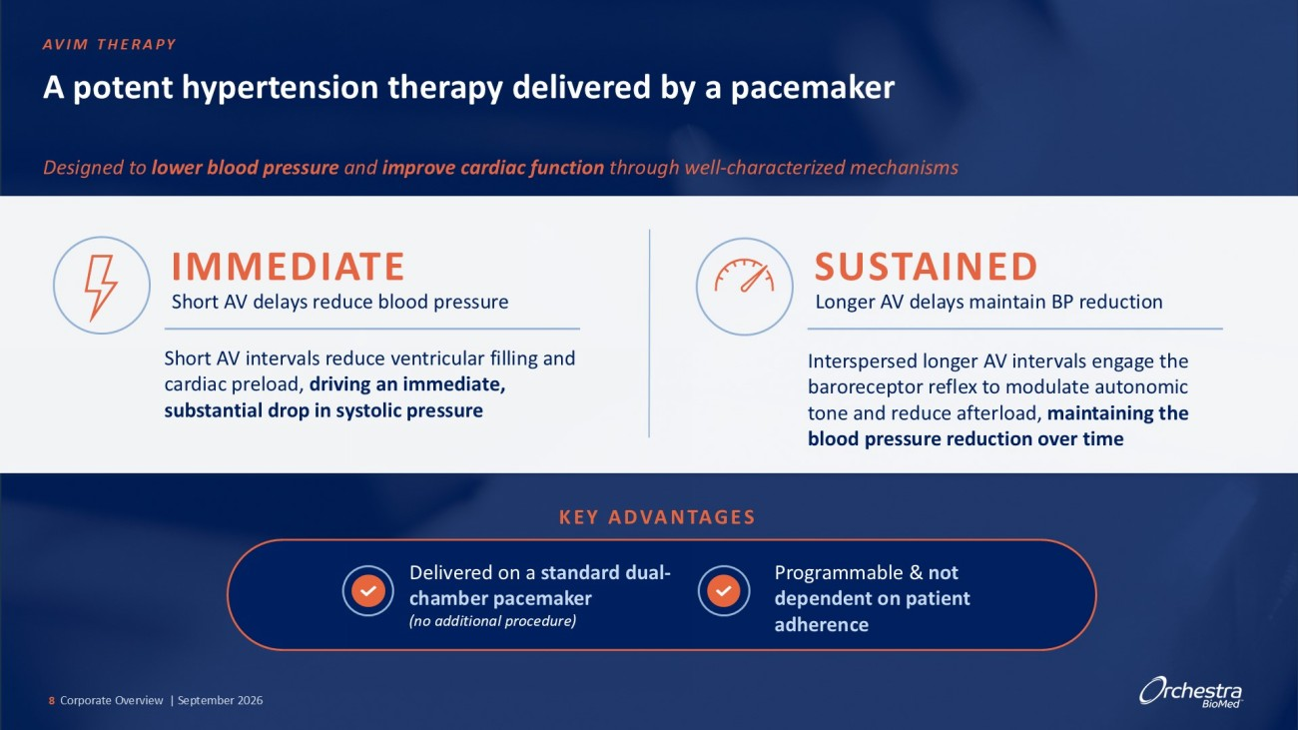
A potent hypertension therapy delivered by a pacemaker Designed to lower blood pressure and improve cardiac function through well - characterized mechanisms Short AV delays reduce blood pressure IMMEDIATE Longer AV delays maintain BP reduction SUSTAINED Short AV intervals reduce ventricular filling and cardiac preload, driving a n immediate, substantial drop in systolic pressure Interspersed longer AV intervals engage the baroreceptor reflex to modulate autonomic tone and reduce afterload, maintaining the blood pressure reduction over time KEY ADVANTAGES Delivered on a standard dual - chamber pacemaker (no additional procedure) Programmable & not dependent on patient adherence AVIM THERAPY 8 Corporate Overview | September 2026

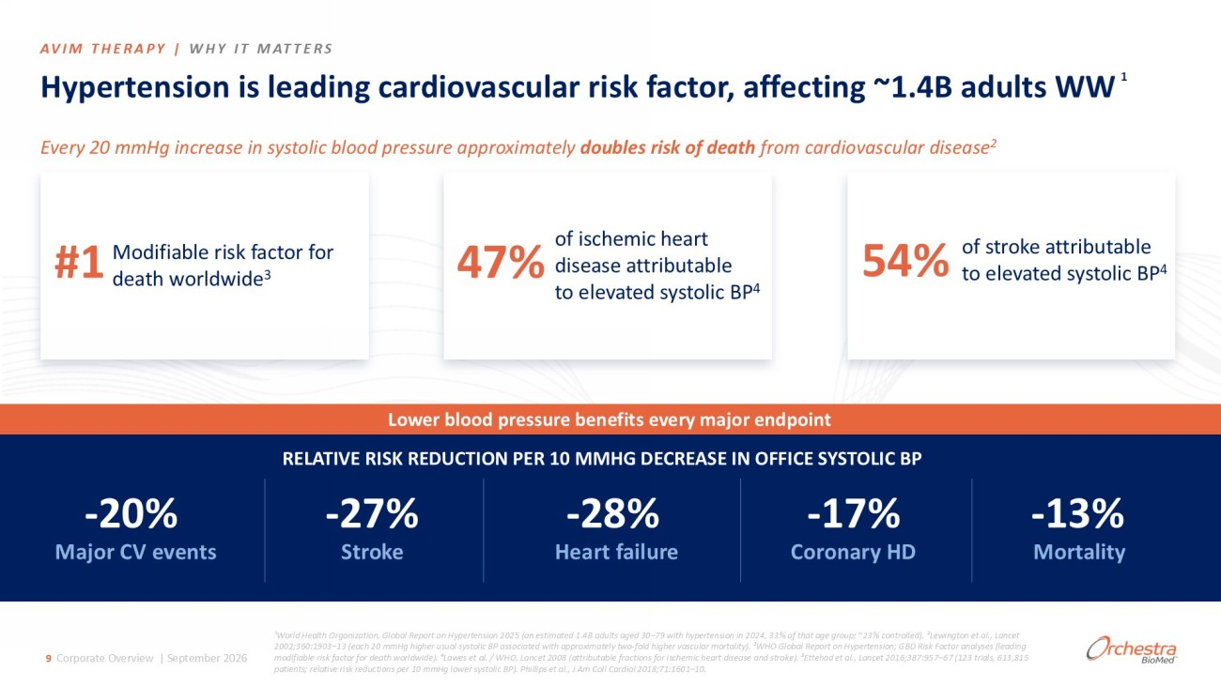
¹World Health Organization, Global Report on Hypertension 2025 (an estimated 1.4B adults aged 30 – 79 with hypertension in 2024, 3 3% of that age group; ~23% controlled). ²Lewington et al., Lancet 2002;360:1903 – 13 (each 20 mmHg higher usual systolic BP associated with approximately two - fold higher vascular mortality). ³WHO Global Report on Hypertension; GBD Risk Factor analyses (leading modifiable risk factor for death worldwide). ⁴Lawes et al. / WHO, Lancet 2008 (attributable fractions for ischemic heart dise ase and stroke). ⁵ Ettehad et al., Lancet 2016;387:957 – 67 (123 trials, 613,815 patients; relative risk reductions per 10 mmHg lower systolic BP). Phillips et al., J Am Coll Cardiol 2018;71:1601 – 10. Hypertension is leading cardiovascular risk factor, affecting ~1.4B adults WW Every 20 mmHg increase in systolic blood pressure approximately doubles risk of death from cardiovascular disease 2 #1 Modifiable risk factor for death worldwide 3 47% of ischemic heart disease attributable to elevated systolic BP 4 54% of stroke attributable to elevated systolic BP 4 Lower blood pressure benefits every major endpoint RELATIVE RISK REDUCTION PER 10 MMHG DECREASE IN OFFICE SYSTOLIC BP - 20% - 27% - 28% - 17% - 13% Major CV events Stroke Heart failure Coronary HD Mortality AVIM THERAPY | WHY IT MATTERS 9 Corporate Overview | September 2026 1

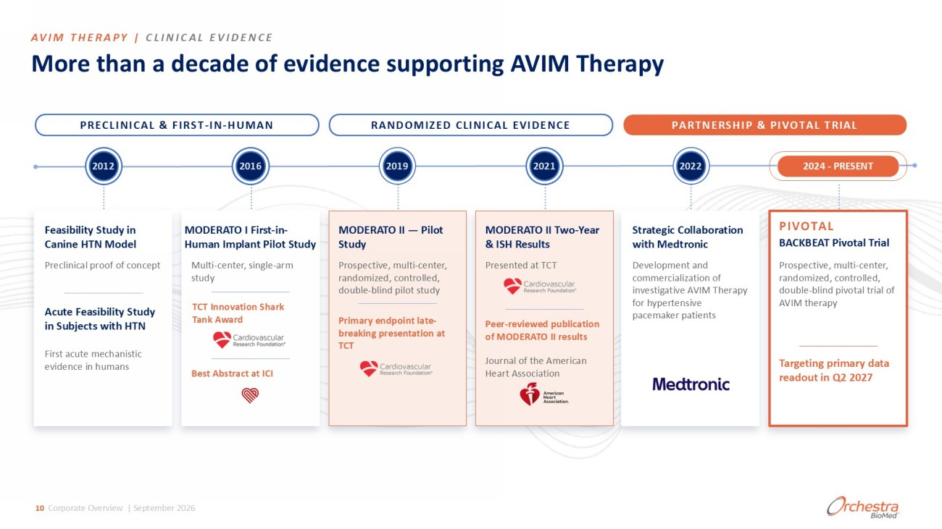
More than a decade of evidence supporting AVIM Therapy PRECLINICAL & FIRST - IN - HUMAN RANDOMIZED CLINICAL EVIDENCE PARTNERSHIP & PIVOTAL TRIAL 2016 2019 2021 2022 Feasibility Study in Canine HTN Model Preclinical proof of concept Acute Feasibility Study in Subjects with HTN First acute mechanistic evidence in humans MODERATO I First - in - Human Implant Pilot Study Multi - center, single - arm study TCT Innovation Shark Tank Award Best Abstract at ICI MODERATO II — Pilot Study Prospective, multi - center, randomized, controlled, double - blind pilot study Primary endpoint late - breaking presentation at TCT MODERATO II Two - Year & ISH Results Presented at TCT Peer - reviewed publication of MODERATO II results Journal of the American Heart Association Strategic Collaboration with Medtronic Development and commercialization of investigative AVIM Therapy for hypertensive pacemaker patients PIVOTAL BACKBEAT Pivotal Trial Prospective, multi - center, randomized, controlled, double - blind pivotal trial of AVIM therapy Targeting primary data readout in Q2 2027 2012 2016 2019 2021 2022 AVIM THERAPY | CLINICAL EVIDENCE 10 Corporate Overview | September 2026 2024 - PRESENT

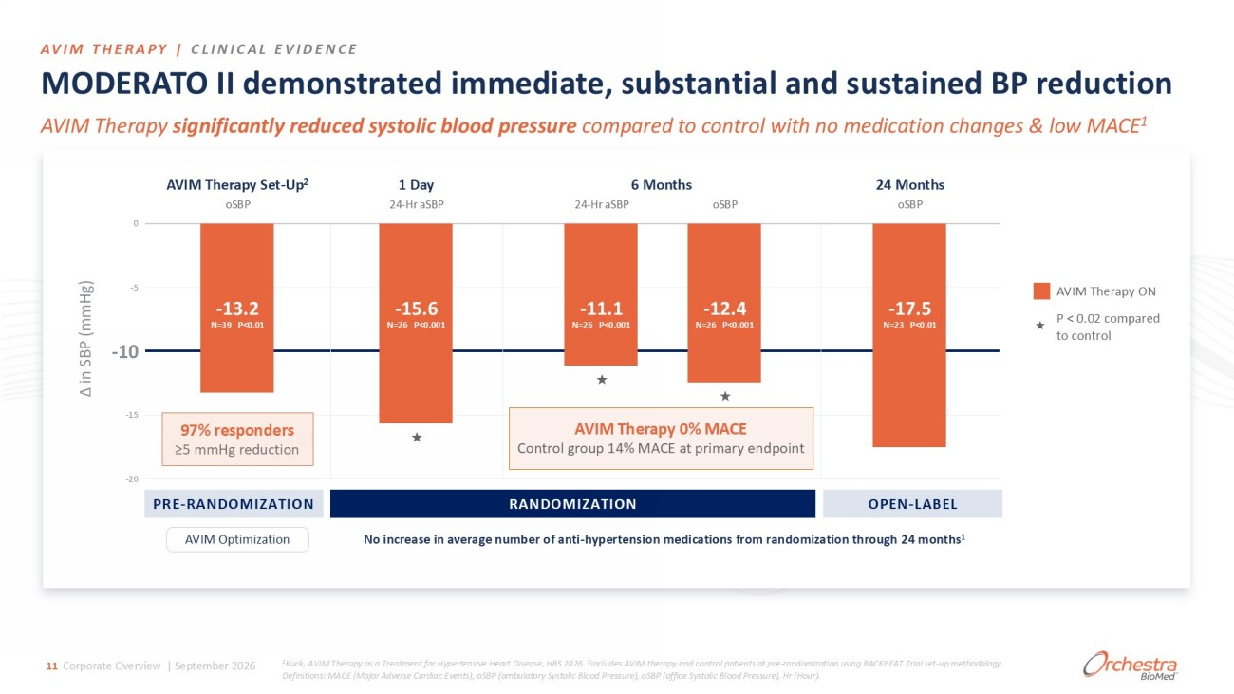
MODERATO II demonstrated immediate, substantial and sustained BP reduction AVIM Therapy significantly reduced systolic blood pressure compared to control with no medication changes & low MACE 1 0 - 5 - 10 - 15 - 20 Δ in SBP (mmHg) AVIM Therapy Set - Up 2 1 Day 6 Months 24 Months oSBP - 13.2 N=39 P<0.01 24 - Hr aSBP - 15.6 N=26 P<0.001 ★ 24 - Hr aSBP - 11.1 N=26 P<0.001 ★ oSBP - 12.4 N=26 P<0.001 ★ oSBP - 17.5 N=23 P<0.01 AVIM Therapy 0% MACE Control group 14% MACE at primary endpoint AVIM Therapy ON ★ P < 0.02 compared to control AVIM Optimization No increase in average number of anti - hypertension medications from randomization through 24 months 1 AVIM THERAPY | CLINICAL EVIDENCE RANDOMIZATION PRE - RANDOMIZATION OPEN - LABEL 1 Kuck, AVIM Therapy as a Treatment for Hypertensive Heart Disease, HRS 2026. 2 Includes AVIM therapy and control patients at pre - randomization using BACKBEAT Trial set - up methodology. Definitions: MACE (Major Adverse Cardiac Events), aSBP (ambulatory Systolic Blood Pressure), oSBP (office Systolic Blood Pressure), Hr (Hour). 11 Corporate Overview | September 2026 97% responders ≥5 mmHg reduction

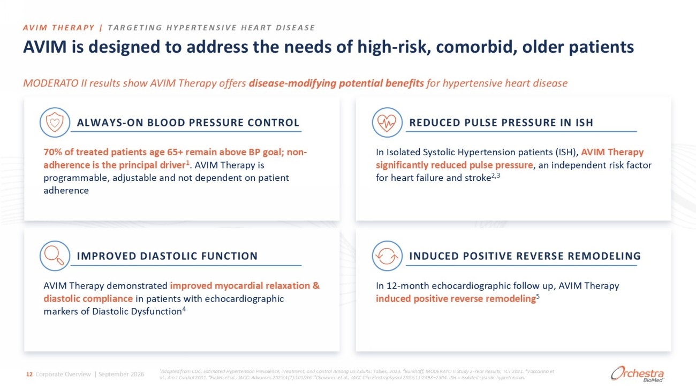
AVIM is designed to address the needs of high - risk, comorbid, older patients MODERATO II results show AVIM Therapy offers disease - modifying potential benefits for hypertensive heart disease REDUCED PULSE PRESSURE IN ISH In Isolated Systolic Hypertension patients (ISH), AVIM Therapy significantly reduced pulse pressure , an independent risk factor for heart failure and stroke 2,3 IMPROVED DIASTOLIC FUNCTION AVIM Therapy demonstrated improved myocardial relaxation & diastolic compliance in patients with echocardiographic markers of Diastolic Dysfunction 4 INDUCED POSITIVE REVERSE REMODELING In 12 - month echocardiographic follow up, AVIM Therapy induced positive reverse remodeling 5 ALWAYS - ON BLOOD PRESSURE CONTROL 70% of treated patients age 65+ remain above BP goal; non - adherence is the principal driver 1 . AVIM Therapy is programmable, adjustable and not dependent on patient adherence AVIM THERAPY | TARGETING HYPERTENSIVE HEART DISEASE ¹Adapted from CDC, Estimated Hypertension Prevalence, Treatment, and Control Among US Adults: Tables, 2023. ²Burkhoff, MODERA TO II Study 2 - Year Results, TCT 2021. ³Vaccarino et al., Am J Cardiol 2001. ⁴ Fudim et al., JACC: Advances 2025;4(7):101896. ⁵Chovanec et al., JACC Clin Electrophysiol 2025;11:2493 – 2504. ISH = isolated systolic hypertension. 12 Corporate Overview | September 2026

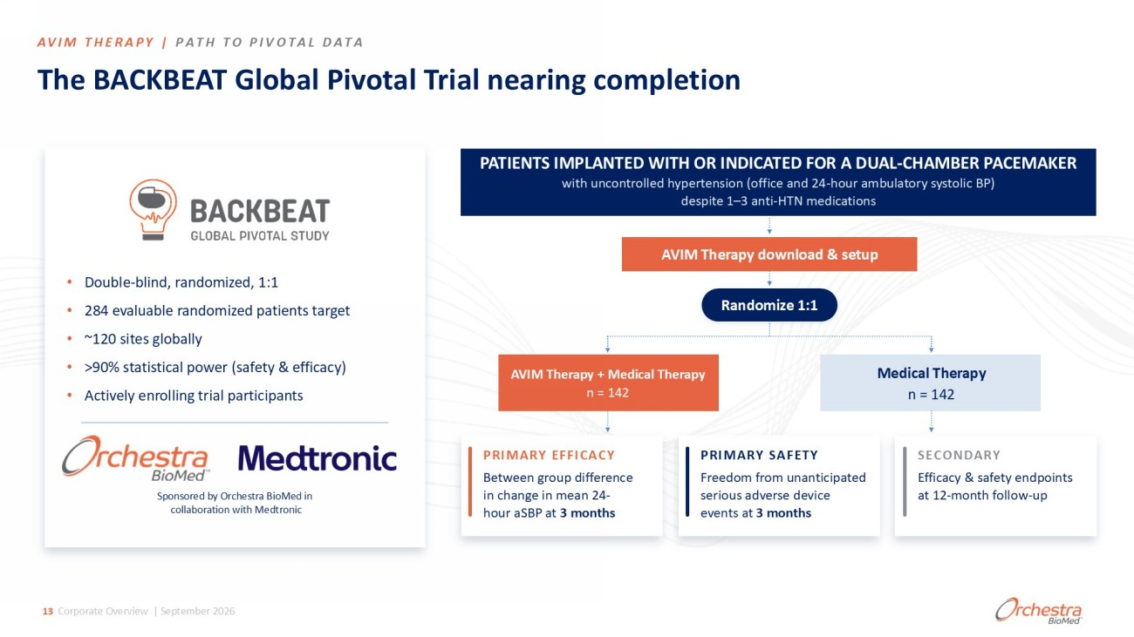
The BACKBEAT Global Pivotal Trial nearing completion • Double - blind, randomized, 1:1 • 284 evaluable randomized patients target • ~120 sites globally • >90% statistical power (safety & efficacy) • Actively enrolling trial participants PATIENTS IMPLANTED WITH OR INDICATED FOR A DUAL - CHAMBER PACEMAKER with uncontrolled hypertension (office and 24 - hour ambulatory systolic BP) despite 1 – 3 anti - HTN medications AVIM Therapy download & setup Randomize 1:1 AVIM Therapy + Medical Therapy n = 142 Medical Therapy n = 142 PRIMARY EFFICACY Between group difference in change in mean 24 - hour aSBP at 3 months PRIMARY SAFETY Freedom from unanticipated serious adverse device events at 3 months SECONDARY Efficacy & safety endpoints at 12 - month follow - up AVIM THERAPY | PATH TO PIVOTAL DATA 13 Corporate Overview | September 2026 Sponsored by Orchestra BioMed in collaboration with Medtronic

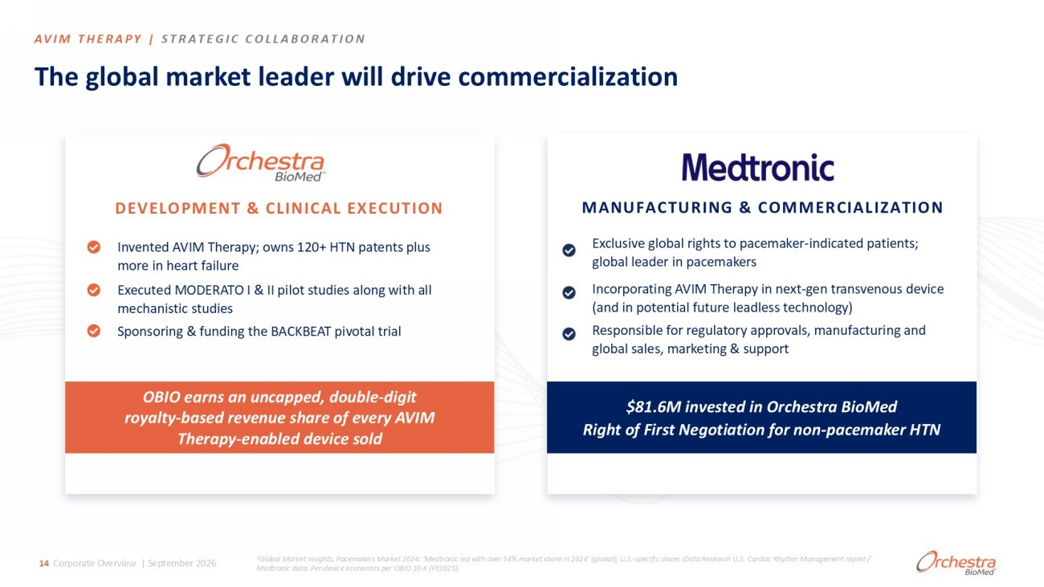
$81.6M invested in Orchestra BioMed Right of First Negotiation for non - pacemaker HTN OBIO earns an uncapped, double - digit royalty - based revenue share of every AVIM Therapy - enabled device sold The global market leader will drive commercialization DEVELOPMENT & CLINICAL EXECUTION Invented AVIM Therapy; owns 120+ HTN patents plus more in heart failure Executed MODERATO I & II pilot studies along with all mechanistic studies Sponsoring & funding the BACKBEAT pivotal trial MANUFACTURING & COMMERCIALIZATION Incorporating AVIM Therapy in next - gen transvenous device (and in potential future leadless technology) Exclusive global rights to pacemaker - indicated patients; global leader in pacemakers Responsible for regulatory approvals, manufacturing and global sales, marketing & support 1 Global Market Insights, Pacemakers Market 2024: 'Medtronic led with over 54% market share in 2024' (global); U.S. - specific share : iData Research U.S. Cardiac Rhythm Management report / Medtronic data. Per - device economics per OBIO 10 - K (FY2025). AVIM THERAPY | STRATEGIC COLLABORATION 14 Corporate Overview | September 2026

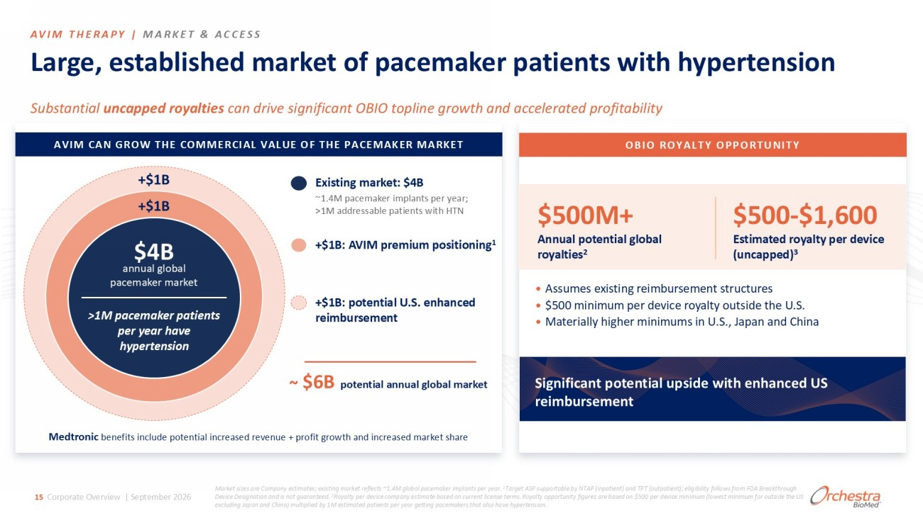
Large, established market of pacemaker patients with hypertension S ubstantial uncapped royalties can drive significant OBIO topline growth and accelerated profitability AVIM THERAPY | MARKET & ACCESS $4B annual global pacemaker market >1M pacemaker patients per year have hypertension +$1B +$1B Existing market: $4B ~1.4M pacemaker implants per year; >1M addressable patients with HTN +$1B: AVIM premium positioning 1 +$1B: potential U.S. enhanced reimbursement $6B potential annual global market OBIO ROYALTY OPPORTUNITY $500 - $1,600 Estimated royalty per device (uncapped) 3 • Assumes existing reimbursement structures • $500 minimum per device royalty outside the U.S. • Materially higher minimums in U.S., Japan and China ~ AVIM CAN GROW THE COMMERCIAL VALUE OF THE PACEMAKER MARKET Significant potential upside with enhanced US reimbursement $500M+ Annual potential global royalties 2 15 Corporate Overview | September 2026 Medtronic benefits include potential increased revenue + profit growth and increased market share Market sizes are Company estimates; existing market reflects ~1.4M global pacemaker implants per year. 1 Target ASP supportable by NTAP (inpatient) and TPT (outpatient); eligibility follows from FDA Breakthrough Device Designation and is not guaranteed. 2 Royalty per device company estimate based on current license terms. Royalty opportunity figures are based on $500 per device minimum (lowest minimum for outside the US excluding Japan and China) multiplied by 1M estimated patients per year getting pacemakers that also have hypertension.

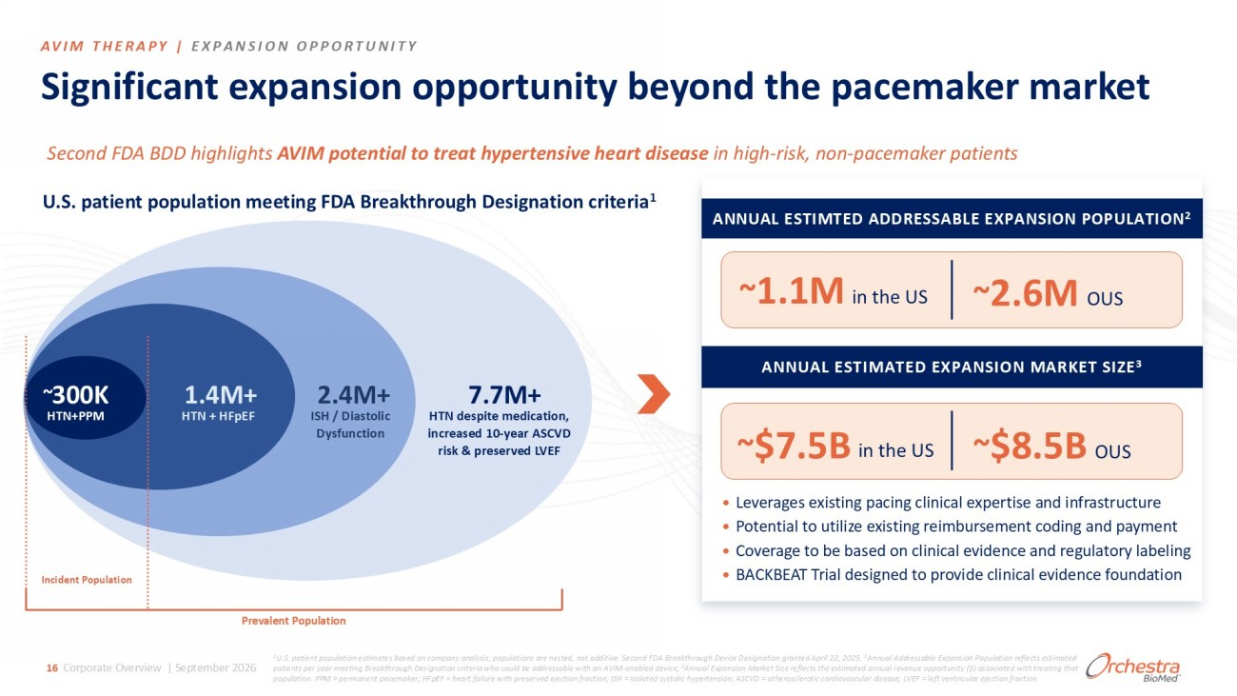
Significant expansion opportunity beyond the pacemaker market 7.7M+ HTN despite medication, increased 10 - year ASCVD risk & preserved LVEF 2.4M+ ISH / Diastolic Dysfunction 1.4M+ HTN + HFpEF 300K HTN+PPM 1 U.S. patient population estimates based on company analysis; populations are nested, not additive. Second FDA Breakthrough De vic e Designation granted April 22, 2025. 2 Annual Addressable Expansion Population reflects estimated patients per year meeting Breakthrough Designation criteria who could be addressable with an AVIM - enabled device; 3 Annual Expansion Market Size reflects the estimated annual revenue opportunity ($) associated with treating that population. PPM = permanent pacemaker; HFpEF = heart failure with preserved ejection fraction; ISH = isolated systolic hypert ens ion; ASCVD = atherosclerotic cardiovascular disease; LVEF = left ventricular ejection fraction. Second FDA BDD highlights AVIM potential to treat hypertensive heart disease in high - risk, non - pacemaker patients ANNUAL ESTIMTED ADDRESSABLE EXPANSION POPULATION 2 ANNUAL ESTIMATED EXPANSION MARKET SIZE 3 • Leverages existing pacing clinical expertise and infrastructure • Potential to utilize existing reimbursement coding and payment • Coverage to be based on clinical evidence and regulatory labeling • BACKBEAT Trial designed to provide clinical evidence foundation Incident Population Prevalent Population U.S. patient population meeting FDA Breakthrough Designation criteria 1 ~ ~ ~ ~ AVIM THERAPY | EXPANSION OPPORTUNITY 16 Corporate Overview | September 2026 ~ 2.6M OUS ~ 1.1M in the US OUS in the US ~ $8.5B ~ $7.5B

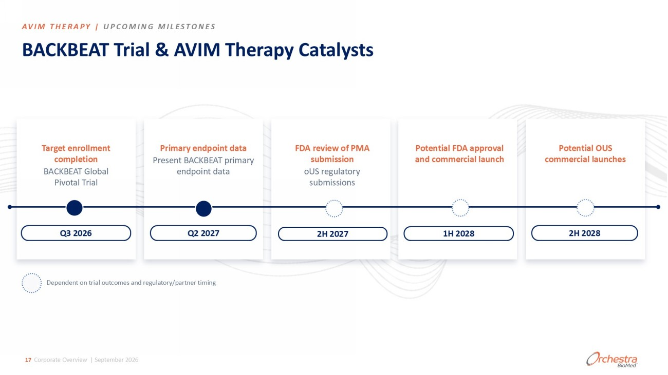
2H 2027 Q2 2027 BACKBEAT Trial & AVIM Therapy Catalysts Target enrollment completion BACKBEAT Global Pivotal Trial Primary endpoint data Present BACKBEAT primary endpoint data FDA review of PMA submission oUS regulatory submissions Potential FDA approval and commercial launch Potential OUS commercial launches Dependent on trial outcomes and regulatory/partner timing Q3 2026 1H 2028 2H 2028 AVIM THERAPY | UPCOMING MILESTONES 17 Corporate Overview | September 2026

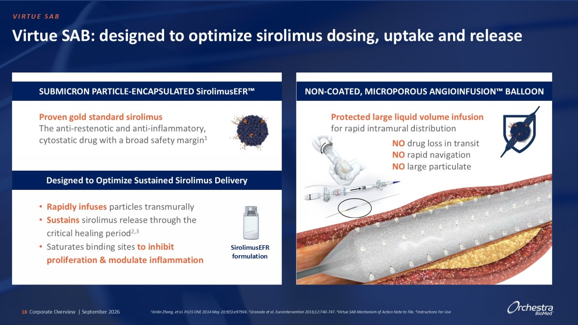
Proven gold standard sirolimus The anti - restenotic and anti - inflammatory, cytostatic drug with a broad safety margin 1 Virtue SAB: designed to optimize sirolimus dosing, uptake and release SirolimusEFR formulation • Rapidly infuses particles transmurally • Sustains sirolimus release through the critical healing period 2,3 • Saturates binding sites to inhibit proliferation & modulate inflammation NO drug loss in transit NO rapid navigation NO large particulate VIRTUE SAB SUBMICRON PARTICLE - ENCAPSULATED SirolimusEFR Designed to Optimize Sustained Sirolimus Delivery EKE Ͳ Kd͕D/ZKWKZKh^E'/K/E&h^/KE >>KKE 18 Corporate Overview | September 2026 1 Xinlin Zhang, et al. PLOS ONE 2014 May 20;9(5):e97934. 2 Granada et al. EuroIntervention 2016;12:740 - 747. 3 Virtue SAB Mechanism of Action Note to File. 4 Instructions For Use Protected large liquid volume infusion for rapid intramural distribution

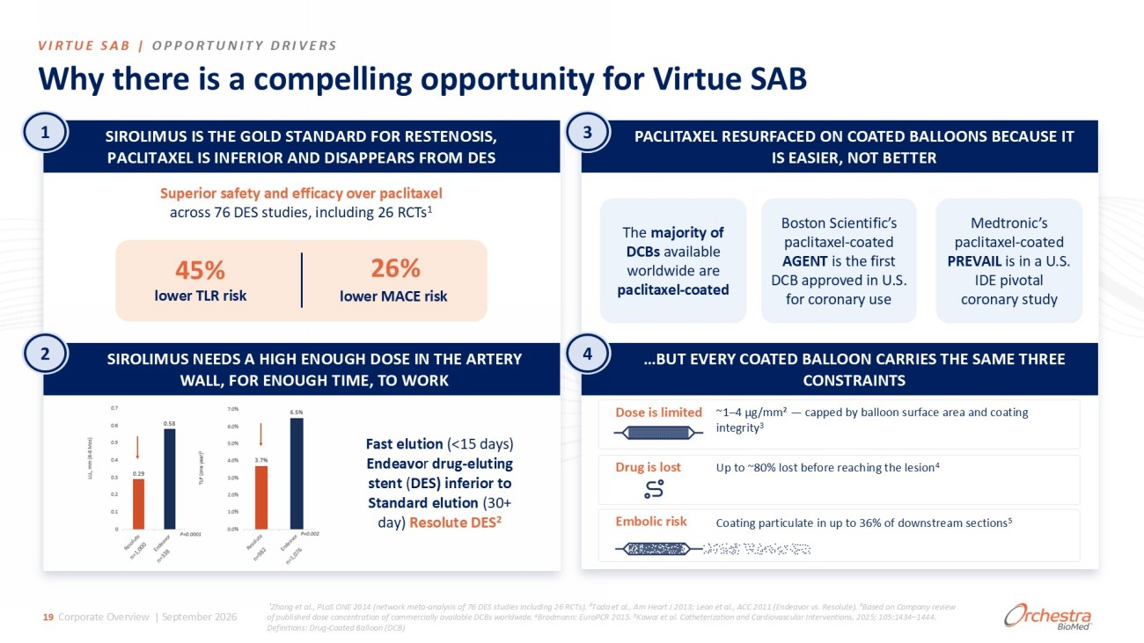
Why there is a compelling opportunity for Virtue SAB VIRTUE SAB | OPPORTUNITY DRIVERS 19 Corporate Overview | September 2026 Superior safety and efficacy over paclitaxel across 76 DES studies, including 26 RCTs 1 &ĂƐƚĞůƵƚŝŽŶ ;ф ϭϱ ĚĂǇƐͿ ŶĚĞĂǀŽ ƌ ĚƌƵŐ Ͳ ĞůƵƚŝŶŐ ƐƚĞŶƚ ; ^Ϳ ŝŶĨĞƌŝŽƌƚŽ ^ƚĂŶĚĂƌĚĞůƵƚŝŽŶ ; ϯϬ н ĚĂǇͿ ZĞƐŽůƵƚĞ ^ Ϯ Dose is limited ~1 – 4 µg/mm² — capped by balloon surface area and coating integrity 3 Drug is lost Up to ~80% lost before reaching the lesion 4 Embolic risk Coating particulate in up to 36% of downstream sections 5 45% ůŽǁĞƌd>ZƌŝƐŬ 26% lower MACE risk The majority of DCBs available worldwide are paclitaxel - coated Boston Scientific’s paclitaxel - coated AGENT is the first DCB approved in U.S. for coronary use Medtronic’s paclitaxel - coated PREVAIL is in a U.S. IDE pivotal coronary study ¹Zhang et al., PLoS ONE 2014 (network meta - analysis of 76 DES studies including 26 RCTs). ²Tada et al., Am Heart J 2013; Leon et al., ACC 2011 (End eavor vs. Resolute). ³Based on Company review of published dose concentration of commercially available DCBs worldwide . 4 Brodmann: EuroPCR 2015. 5 Kawai et al. Catheterization and Cardiovascular Interventions, 2025; 105:1434 – 1444. Definitions: Drug - Coated Balloon (DCB) 1 ^/ZK>/Dh^/^d,'K>^dEZ&KZZ^dEK^/^͕ W>/dy>/^/E&Z/KZE/^WWZ^&ZKD^ SIROLIMUS NEEDS A HIGH ENOUGH DOSE IN THE ARTERY WALL, FOR ENOUGH TIME, TO WORK 2 PACLITAXEL RESURFACED ON COATED BALLOONS BECAUSE IT IS EASIER, NOT BETTER …BUT EVERY COATED BALLOON CARRIES THE SAME THREE CONSTRAINTS 3 4

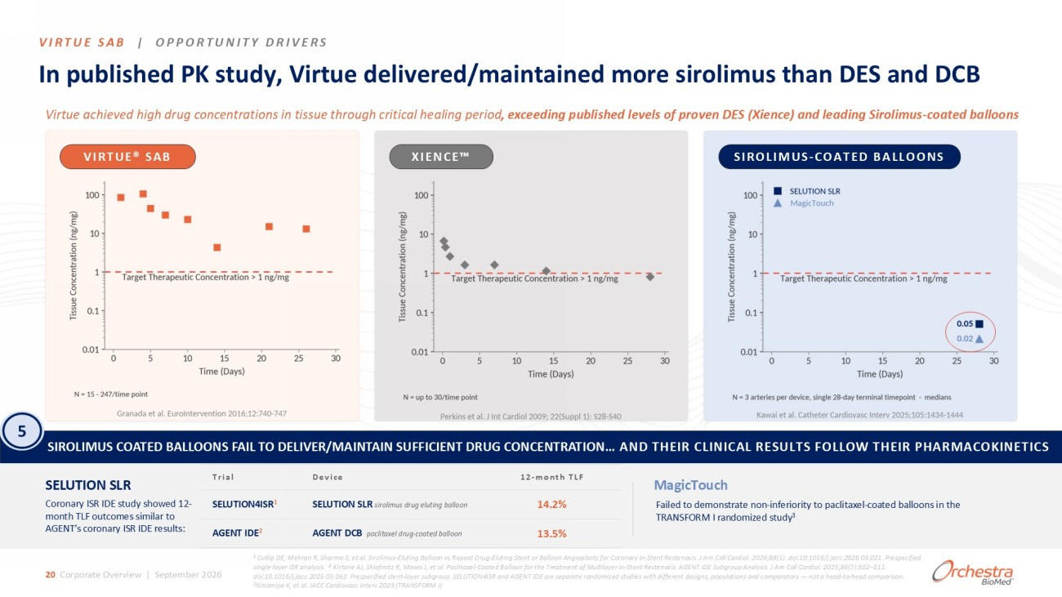
VIRTUE SAB | OPPORTUNITY DRIVERS /ŶƉƵďůŝƐŚĞĚW<ƐƚƵĚǇ͕sŝƌƚƵĞĚĞůŝǀĞƌĞĚͬŵĂŝŶƚĂŝŶĞĚŵŽƌĞƐŝƌŽůŝŵƵƐƚŚĂŶ^ĂŶĚ Virtue achieved high drug concentrations in tissue through critical healing period , exceeding published levels of proven DES ( Xience ) and leading Sirolimus - coated balloons VIRTUE® SAB XIENCE SIROLIMUS - COATED BALLOONS SIROLIMUS COATED BALLOONS FAIL TO DELIVER/MAINTAIN SUFFICIENT DRUG CONCENTRATION … AND THEIR CLINICAL RESULTS FOLLOW THEIR PHARMACOKINETICS SELUTION SLR Coronary ISR IDE study showed 12 - month TLF outcomes similar to AGENT’s coronary ISR IDE results: DĂŐŝĐdŽƵĐŚ Failed to demonstrate non - inferiority to paclitaxel - coated balloons in the TRANSFORM I randomized study 3 20 Corporate Overview | September 2026 12 - month TLF Device Trial 14.2% SELUTION SLR sirolimus drug eluting balloon SELUTION4ISR 1 13.5% AGENT DCB paclitaxel drug - coated balloon AGENT IDE 2 1 Cutlip DE, Mehran R, Sharma S, et al. Sirolimus - Eluting Balloon vs Repeat Drug - Eluting Stent or Balloon Angioplasty for Coronar y In - Stent Restenosis. J Am Coll Cardiol . 2026;88(1). doi:10.1016/j.jacc.2026.03.021. Prespecified single - layer ISR analysis. 2 Kirtane AJ, Shlofmitz R, Moses J, et al. Paclitaxel - Coated Balloon for the Treatment of Multilayer In - Stent Restenosis: AGENT IDE Subgroup Analysis. J Am Coll Cardiol . 2025;86(7):502 – 511. doi:10.1016/j.jacc.2025.05.062. Prespecified stent - layer subgroup. SELUTION4ISR and AGENT IDE are separate randomized studies wi th different designs, populations and comparators — not a head - to - head comparison. 3 Ninomiya K, et al. JACC Cardiovasc Interv 2023 (TRANSFORM I) 5

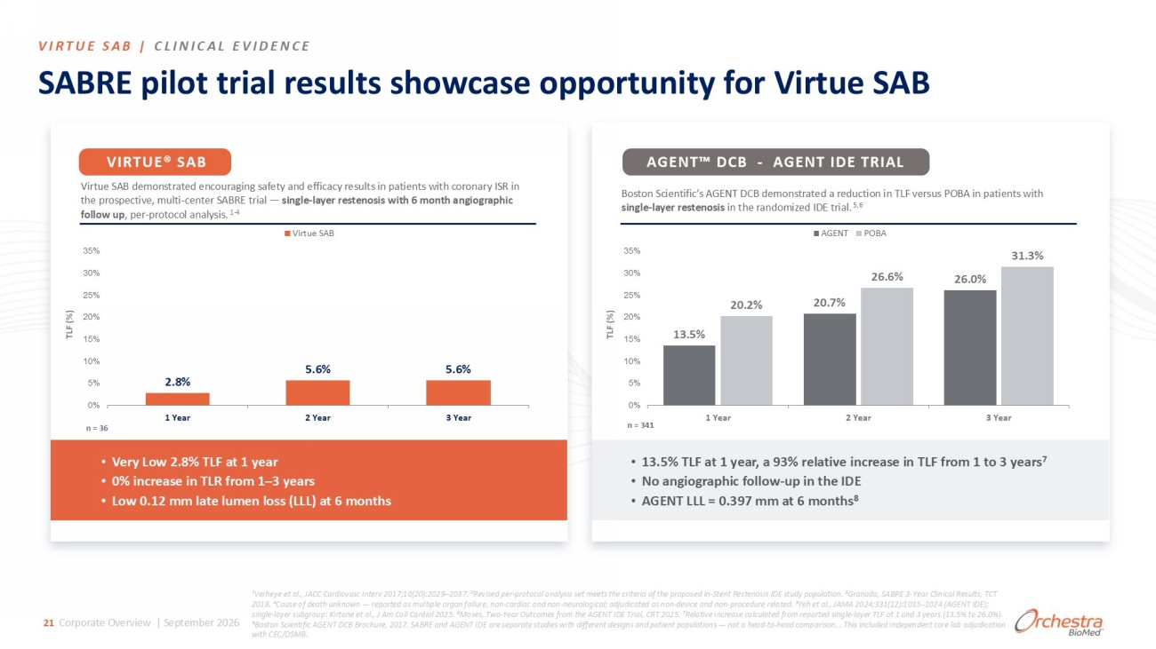
SABRE pilot trial results showcase opportunity for Virtue SAB Virtue SAB demonstrated encouraging safety and efficacy results in patients with coronary ISR in the prospective, multi - center SABRE trial — single - layer restenosis with 6 month angiographic follow up , per - protocol analysis. 1 - 4 2.8% ϱ͘ϲ й 5.6% 0% 5% 10% 15% 20% 25% 30% 35% 1 Year 2 Year 3 Year Virtue SAB • Very Low 2.8% TLF at 1 year • 0% increase in TLR from 1 – 3 years • Low 0.12 mm late lumen loss (LLL) at 6 months n = 341 Boston Scientific’s AGENT DCB demonstrated a reduction in TLF versus POBA in patients with single - layer restenosis in the randomized IDE trial. 5,6 13.5% 20.7% 26.0% ϮϬ͘Ϯ й 26.6% 31.3% 0% 5% 10% 15% 20% 25% 30% 35% 1 Year 2 Year 3 Year AGENT POBA • 13.5% TLF at 1 year, a 93% relative increase in TLF from 1 to 3 years 7 • No angiographic follow - up in the IDE • AGENT LLL = 0.397 mm at 6 months 8 ¹Verheye et al., JACC Cardiovasc Interv 2017;10(20):2029 – 2037. ²Revised per - protocol analysis set meets the criteria of the proposed In - Stent Restenosis IDE study popu lation. ³Granada, SABRE 3 - Year Clinical Results, TCT 2018. ⁴Cause of death unknown — reported as multiple organ failure, non - cardiac and non - neurological; adjudicated as non - device and non - procedure related. ⁵Yeh et al., JAMA 2024;331(12):1015 – 1024 (AGENT IDE); single - layer subgroup: Kirtane et al., J Am Coll Cardiol 2025. ⁶Moses, Two - Year Outcomes from the AGENT IDE Trial, CRT 2025. ⁷Relative increase calculated from reported single - layer TL F at 1 and 3 years (13.5% to 26.0%). ⁸Boston Scientific AGENT DCB Brochure, 2017. SABRE and AGENT IDE are separate studies with different designs and patient popu lat ions — not a head - to - head comparison. . This included independent core lab adjudication with CEC/DSMB. TLF (%) TLF (%) n = 36 s/Zdh^ͮ >/E/>s/E 21 Corporate Overview | September 2026 VIRTUE® SAB AGENT DCB - AGENT IDE TRIAL

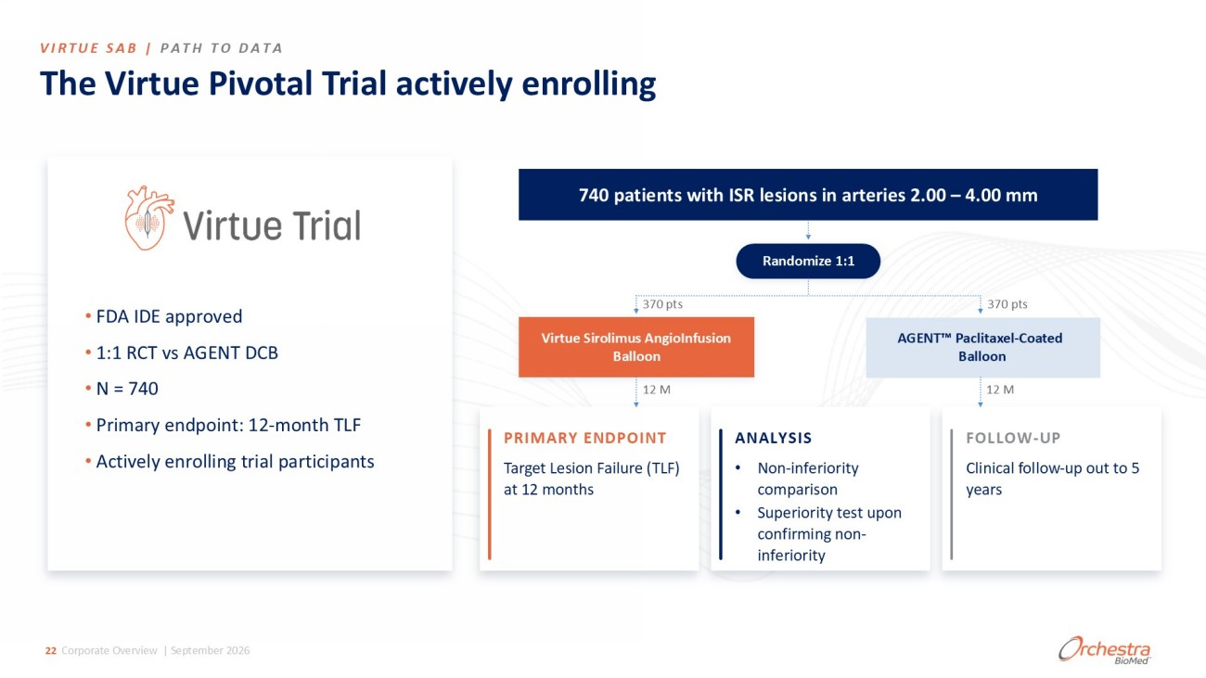
The Virtue Pivotal Trial actively enrolling 740 patients with ISR lesions in arteries 2.00 – 4.00 mm Randomize 1:1 370 pts ϯϳϬ ƉƚƐ Virtue Sirolimus AngioInfusion Balloon AGENT Paclitaxel - Coated Balloon 12 M 12 M PRIMARY ENDPOINT Target Lesion Failure (TLF) at 12 months ANALYSIS  EŽŶ Ͳ ŝŶĨĞƌŝŽƌŝƚǇ ĐŽŵƉĂƌŝƐŽŶ  ^ƵƉĞƌŝŽƌŝƚǇ ƚĞƐƚƵƉŽŶ ĐŽŶĨŝƌŵŝŶŐŶŽŶ Ͳ ŝŶĨĞƌŝŽƌŝƚǇ FOLLOW - UP Clinical follow - up out to 5 years • FDA IDE approved • 1:1 RCT vs AGENT DCB • N = 740 • Primary endpoint: 12 - month TLF • Actively enrolling trial participants VIRTUE SAB | PATH TO DATA 22 Corporate Overview | September 2026

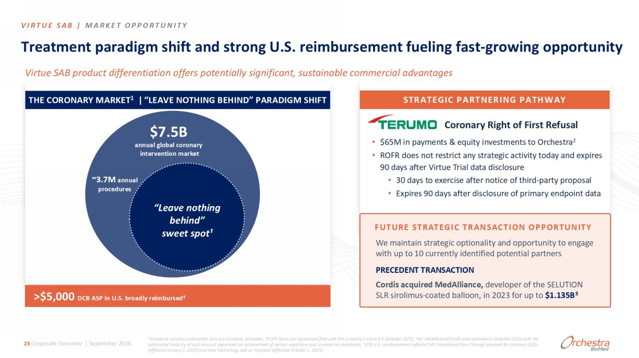
Virtue SAB product differentiation offers potentially significant, sustainable commercial advantages • $65M in payments & equity investments to Orchestra 2 • ROFR does not restrict any strategic activity today and expires 90 days after Virtue Trial data disclosure • 30 days to exercise after notice of third - party proposal • Expires 90 days after disclosure of primary endpoint data dƌĞĂƚŵĞŶƚƉĂƌĂĚŝŐŵƐŚŝĨƚĂŶĚƐƚƌŽŶŐh͘^͘ƌĞŝŵďƵƌƐĞŵĞŶƚĨƵĞůŝŶŐĨĂƐƚ Ͳ ŐƌŽǁŝŶŐŽƉƉŽƌƚƵŶŝƚǇ THE CORONARY MARKET 1 | “LEAVE NOTHING BEHIND” PARADIGM SHIFT $7.5B annual global coronary intervention market ~3.7M annual procedures “Leave nothing behind” sweet spot¹ >$5,000 DCB ASP in U.S. broadly reimbursed 4 ¹Procedure volumes and market sizes are Company estimates. ²ROFR terms per agreement filed with the Company's Form 8 - K (October 2025). 3 Per MedAlliance /Cordis announcements (October 2023) with the substantial majority of such amount dependent on achievement of certain regulatory and commercial milestones. 4 DCB U.S. reimbursement reflects CMS Transitional Pass - Through payment for coronary DCBs (effective January 1, 2025) and New Technology Add - on Payment (effective October 1, 2025). s/Zdh^ͮ DZ<dKWWKZdhE/dz STRATEGIC PARTNERING PATHWAY Coronary Right of First Refusal 23 Corporate Overview | September 2026 FUTURE STRATEGIC TRANSACTION OPPORTUNITY We maintain strategic optionality and opportunity to engage with up to 10 currently identified potential partners PRECEDENT TRANSACTION Cordis acquired MedAlliance , developer of the SELUTION SLR sirolimus - coated balloon, in 2023 for up to $ 1.135B 3

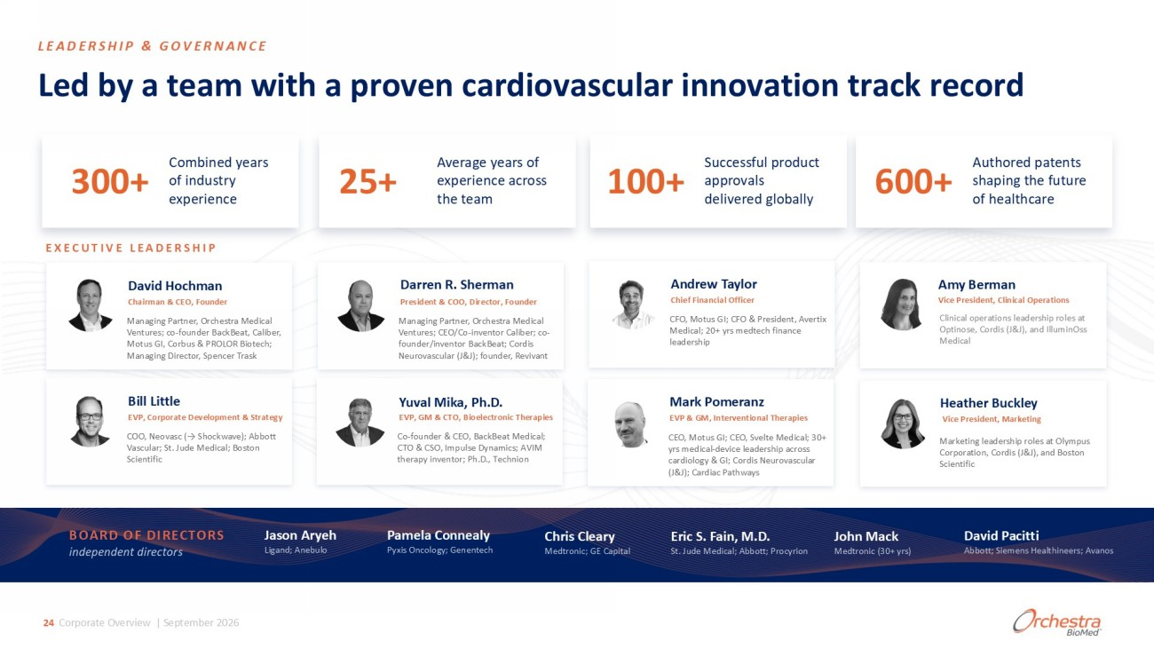
>ĞĚďǇĂƚĞĂŵǁŝƚŚĂƉƌŽǀĞŶĐĂƌĚŝŽǀĂƐĐƵůĂƌŝŶŶŽǀĂƚŝŽŶƚƌĂĐŬƌĞĐŽƌĚ David Hochman Chairman & CEO, Founder Darren R. Sherman President & COO, Director, Founder Andrew Taylor Chief Financial Officer Bill Little sW͕ŽƌƉŽƌĂƚĞĞǀĞůŽƉŵĞŶƚΘ^ƚƌĂƚĞŐǇ COO, Neovasc (→ Shockwave); Abbott Vascular; St. Jude Medical; Boston Scientific Yuval Mika, Ph.D. EVP, GM & CTO, Bioelectronic Therapies Mark Pomeranz EVP & GM, Interventional Therapies EXECUTIVE LEADERSHIP BOARD OF DIRECTORS independent directors :ĂƐŽŶƌǇĞŚ >ŝŐĂŶĚ͖ŶĞďƵůŽ Pamela Connealy Pyxis Oncology; Genentech Chris Cleary Medtronic; GE Capital Eric S. Fain, M.D. St. Jude Medical; Abbott; Procyrion David Pacitti Abbott; Siemens Healthineers ; Avanos John Mack Medtronic (30+ yrs) 300+ Combined years of industry experience Ϯϱ н Average years of experience across the team 100+ Successful product approvals delivered globally 600+ Authored patents shaping the future of healthcare Amy Berman Vice President, Clinical Operations sŝĐĞWƌĞƐŝĚĞŶƚ͕DĂƌŬĞƚŝŶŐ Heather Buckley LEADERSHIP & GOVERNANCE 24 Corporate Overview | September 2026 Managing Partner, Orchestra Medical Ventures; co - founder BackBeat, Caliber, Motus GI, Corbus & PROLOR Biotech; Managing Director, Spencer Trask Managing Partner, Orchestra Medical Ventures; CEO/Co - inventor Caliber; co - founder/inventor BackBeat ; Cordis Neurovascular (J&J); founder, Revivant CFO, Motus GI; CFO & President, Avertix Medical; 20+ yrs medtech finance leadership Clinical operations leadership roles at Optinose, Cordis (J&J), and IlluminOss Medical Ž Ͳ ĨŽƵŶĚĞƌΘK͕ĂĐŬĞĂƚDĞĚŝĐĂů͖ dKΘ^K͕/ŵƉƵůƐĞǇŶĂŵŝĐƐ͖s/D ƚŚĞƌĂƉǇŝŶǀĞŶƚŽƌ͖WŚ͕͘͘dĞĐŚŶŝŽŶ CEO, Motus GI; CEO, Svelte Medical; 30+ yrs medical - device leadership across cardiology & GI; Cordis Neurovascular (J&J); Cardiac Pathways Marketing leadership roles at Olympus Corporation, Cordis (J&J), and Boston Scientific

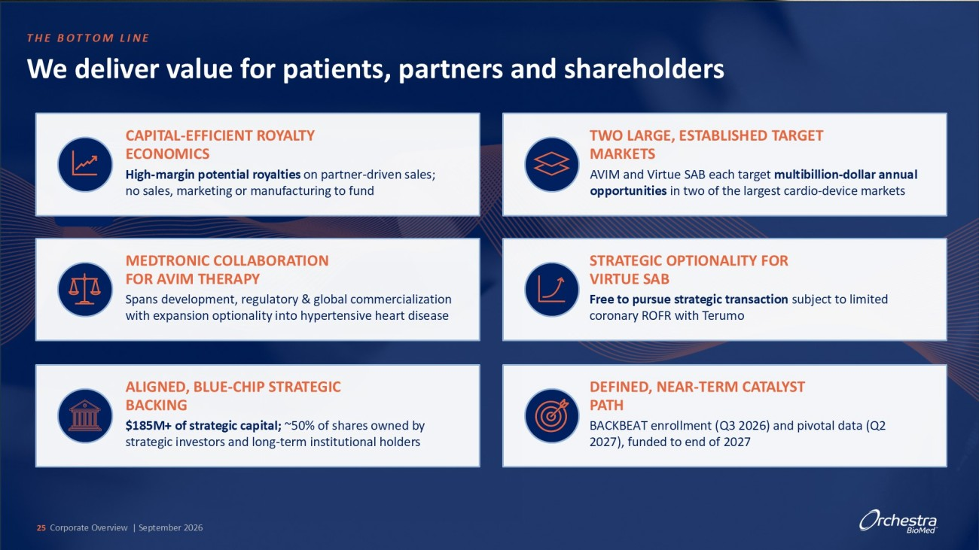
THE BOTTOM LINE CAPITAL - EFFICIENT ROYALTY ECONOMICS High - margin potential royalties on partner - driven sales; no sales, marketing or manufacturing to fund We deliver value for patients, partners and shareholders MEDTRONIC COLLABORATION FOR AVIM THERAPY ^ƉĂŶƐĚĞǀĞůŽƉŵĞŶƚ͕ƌĞŐƵůĂƚŽƌǇΘŐůŽďĂůĐŽŵŵĞƌĐŝĂůŝǌĂƚŝŽŶ ǁŝƚŚĞǆƉĂŶƐŝŽŶŽƉƚŝŽŶĂůŝƚǇŝŶƚŽŚǇƉĞƌƚĞŶƐŝǀĞŚĞĂƌƚĚŝƐĞĂƐĞ ALIGNED, BLUE - CHIP STRATEGIC BACKING $185M+ of strategic capital; ~50% of shares owned by strategic investors and long - term institutional holders TWO LARGE, ESTABLISHED TARGET MARKETS AVIM and Virtue SAB each target multibillion - dollar annual opportunities in two of the largest cardio - device markets STRATEGIC OPTIONALITY FOR VIRTUE SAB Free to pursue strategic transaction subject to limited coronary ROFR with Terumo DEFINED, NEAR - TERM CATALYST PATH <dĞŶƌŽůůŵĞŶƚ;Y ϯϮϬϮϲ ͿĂŶĚƉŝǀŽƚĂůĚĂƚĂ;Y Ϯ ϮϬϮϳ Ϳ͕ĨƵŶĚĞĚƚŽĞŶĚŽĨ ϮϬϮϳ 25 Corporate Overview | September 2026

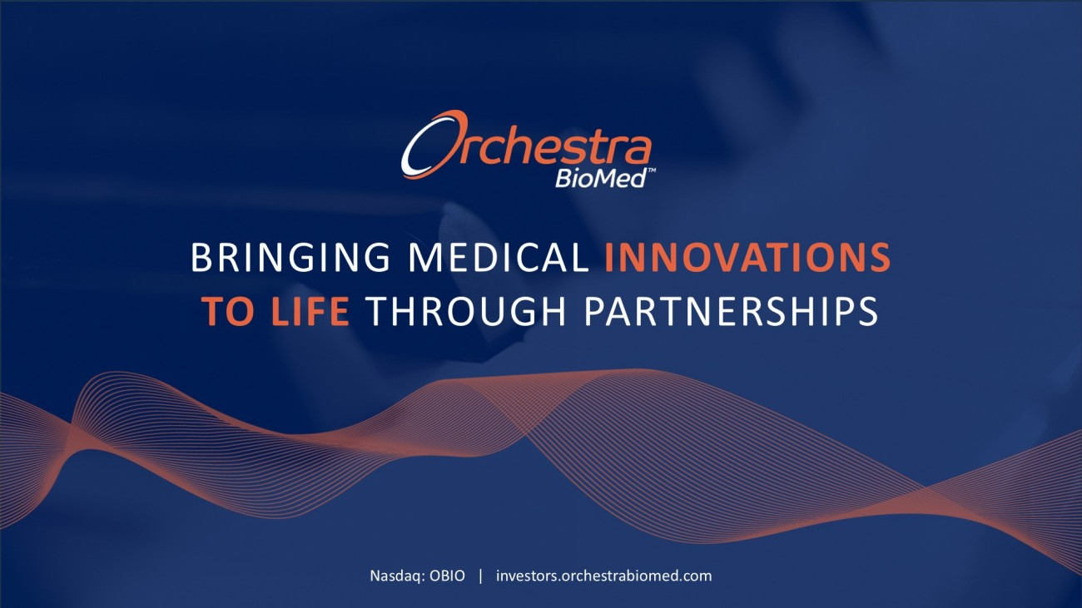
BRINGING MEDICAL INNOVATIONS TO LIFE THROUGH PARTNERSHIPS Nasdaq: OBIO | investors.orchestrabiomed.com

